

Mag. Dr. Thomas Wagner
Proseminar EB2.1 Discourse Linguistics – SABEN05x02 (3 ECTS)

Deixis

- The deictic center 1
cf. Yule, 1996, chapter 2, Deixis and Distance, p. 9

In the cartoon below, how come both chickens assume they are “on the other side”? Refer to the concept of the deictic center for your argument.

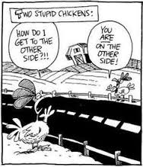

- The deictic center 2
cf. Yule, 1996, chapter 2, Deixis and Distance, p. 9

Describe potential problems with the interpretation of the italicised referring expressions in the message in the bottle below. Refer to the concept of the deictic center for your argument.



Please rescue me! I’ve been here since last month, and my food will run out tomorrow.

- The deictic center 3
cf. Yule, 1996, chapter 2, Deixis and Distance, p. 9

Explain the Irish joke below. Refer to the concept of the deictic center for your argument.

Paddy and Murphy were walking down the road, when Paddy noticed a mirror on the floor. Paddy picked it up and looked into the mirror. “I know this guy in the mirror”, he said. Murphy took the mirror off him, looked into the mirror, and finally said: “Of course you know who it is. It’s me, you idiot!”

- The deictic center 4
cf. Yule, 1996, chapter 2, Deixis and Distance, p. 9

How would you convert the utterance below into indirect speech? How do your changes reflect the concept of distance (proximal vs distal)?

Are you planning to be here this evening?

- Referents – generic, type, token
Birner, 2013, chapter 4.1, Referring Expressions, p. 113 / 73, example (97)

Describe what kind of referent could be behind the italicized referring expressions in example (97) below. Discuss how identifiable, stable, and ‘real’ potential referents are.

(97) | 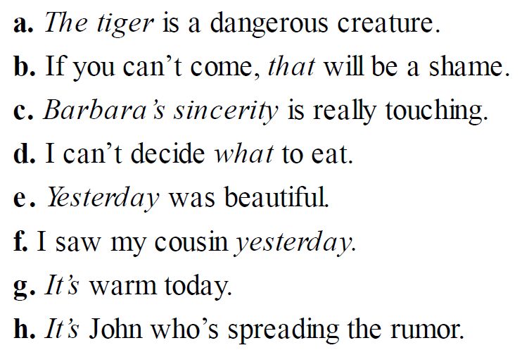

- Deictic versus anaphoric use
Birner, 2013, chapter 4.1, Referring Expressions, p. 138 / 86, example (145b)

Describe, if the final this in example (145b) below is deictic or anaphoric. Argue for one position or the other.

(145b) | I would like the ball to be dropped into Lake Wobegon off Rocky Point. I loved that part of the lake, where our town is obscured behind the trees and you feel that you might be up north on the Boundary Waters. I do not wish any eulogy or public prayers said for me, none at all, thank you, and the only music I want is Andy Williams singing “Moon River,” which was “our song,” mine and Raoul’s, and I’m sorry to have kept all this a secret from you. (Keillor 2007)

